REPORT



PROJECT NAME : ONLINE CRICKET SCORE BOARD

SUBJECT CODE : INT-213(PYTHON)

GROUP MEMBERS :

Shaik Humayun Basha- 11910415

SUBMISSION DATE : 12-11-2020

Github: https://github.com/humayunbasha/my-python-project.py

LOGIN PAGE:

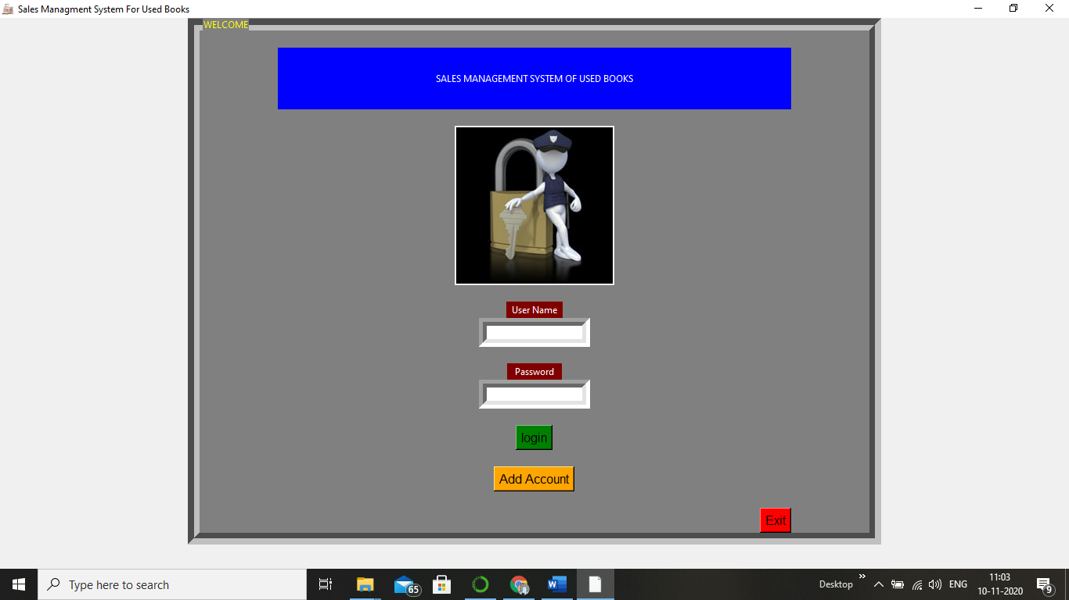

* Here we can create a new account and we can login if we have a account. We created a Exit button and we added a image. Here we take input and we crosscheck with the database were all data is saved.

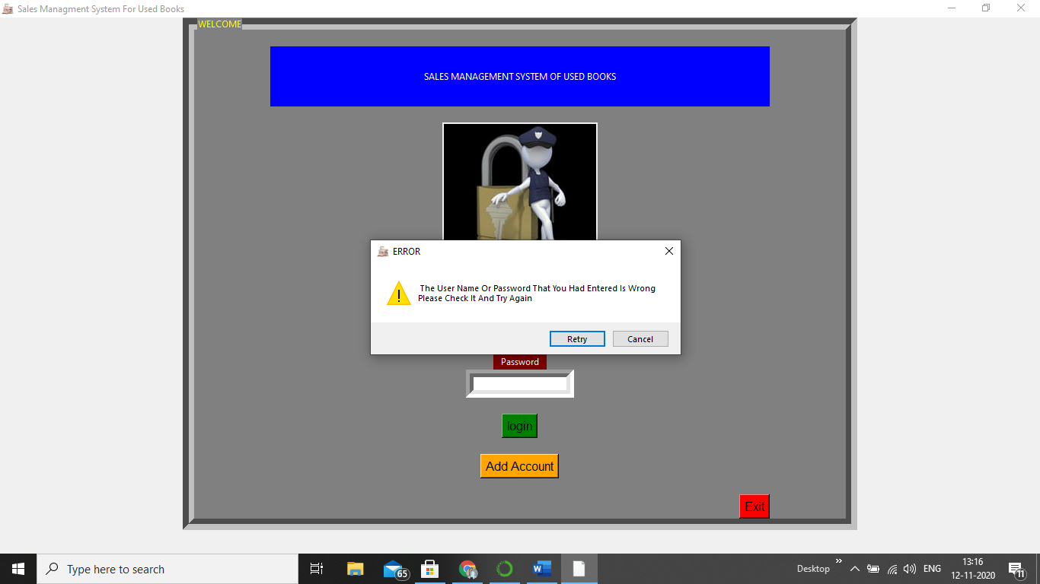

* We added a message which will pop when the username or password are misstyped.
* ADD ACCOUNT

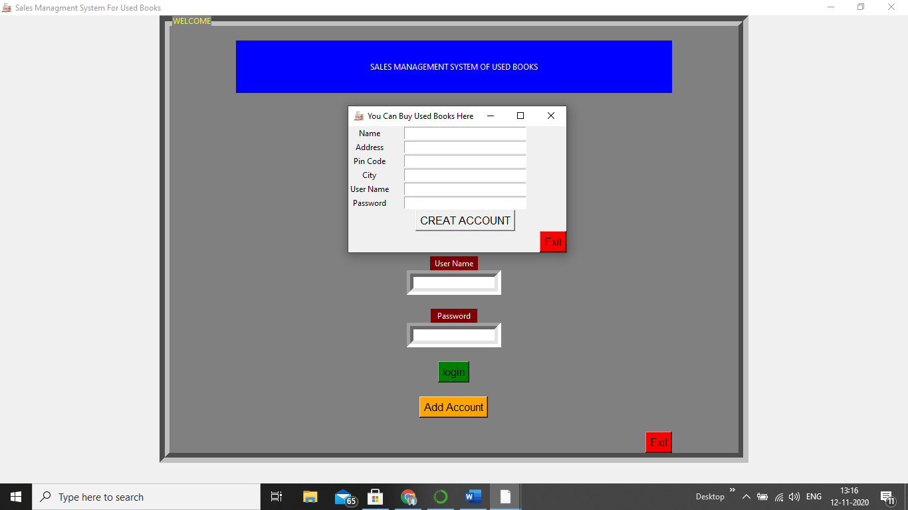

* In add account we take the info of user and we save them in a database and when we use the info in login we tally both of them.
* In LOGIN: 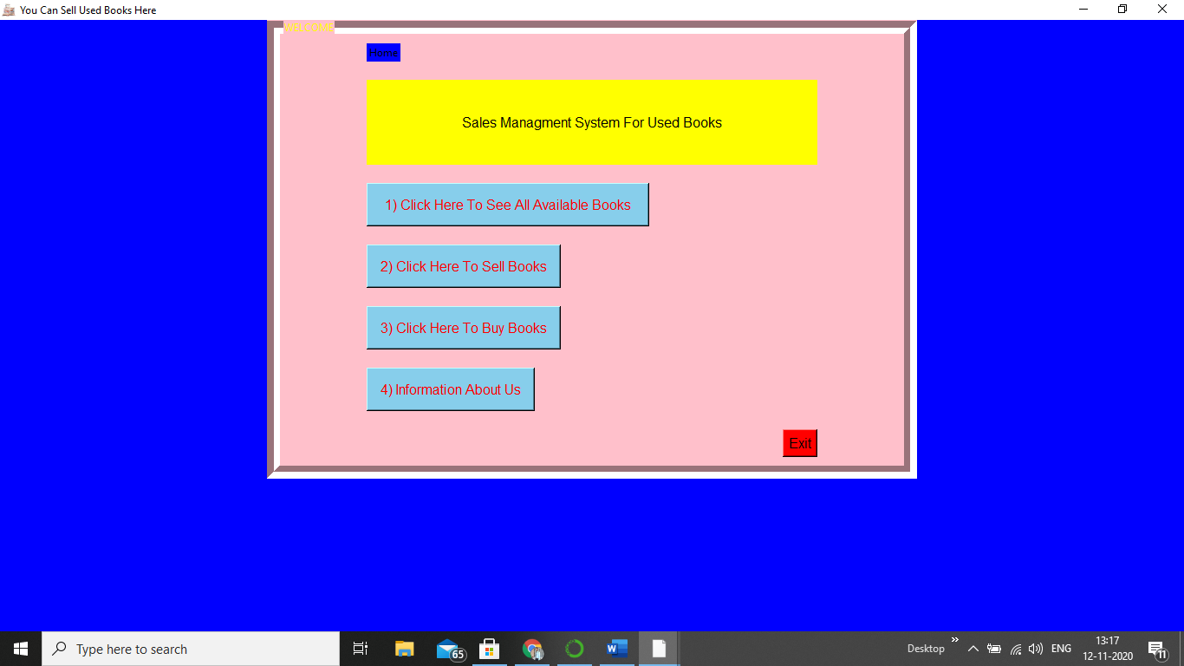

We have 4 options those are to buy books to sell books to see books and to know the info of us

* See all available books

Here by pressing a button which is texted as see all books we can see all books. And we have a home button and a exit button. And we added a moving down and up button.

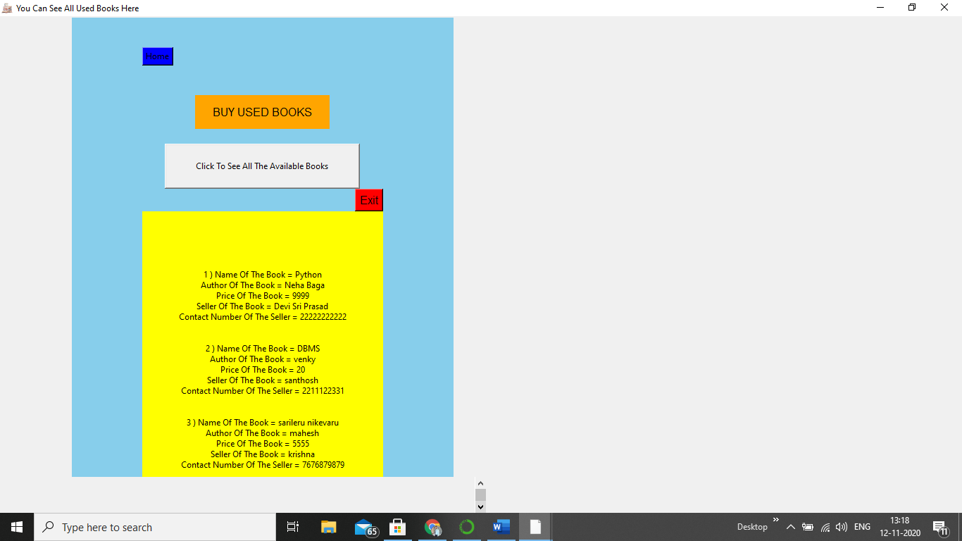

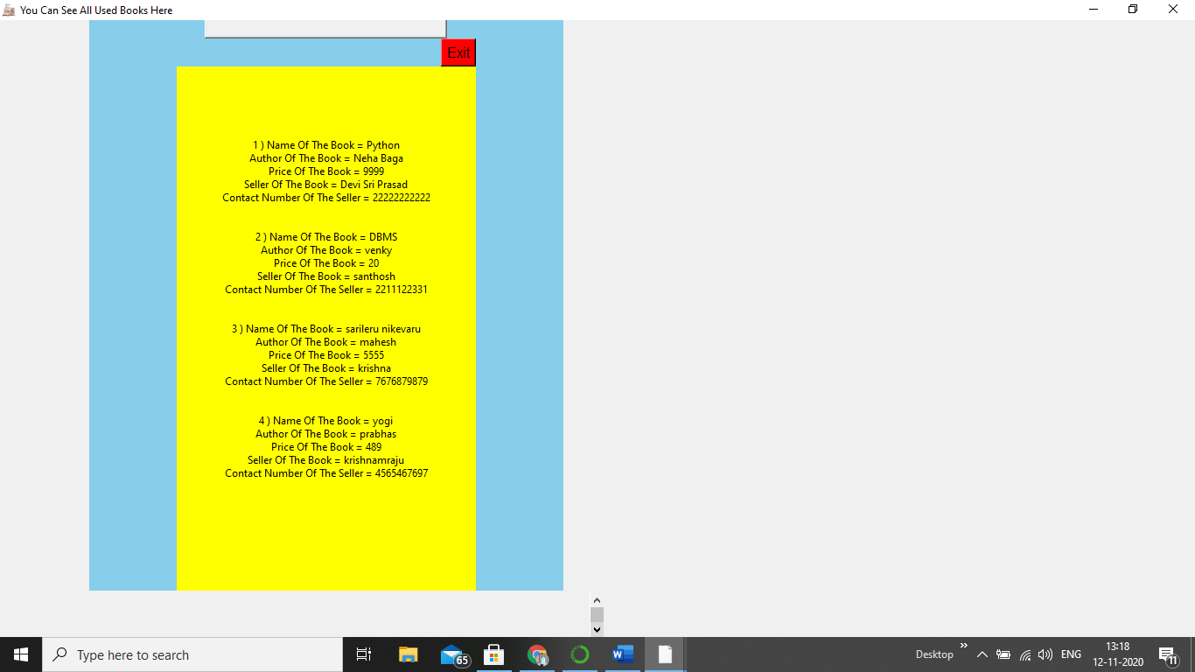

* Sell Used Books

Here we can sell all our used books by giving our information and fixing a price for it. Here we have a home button and a exit button.

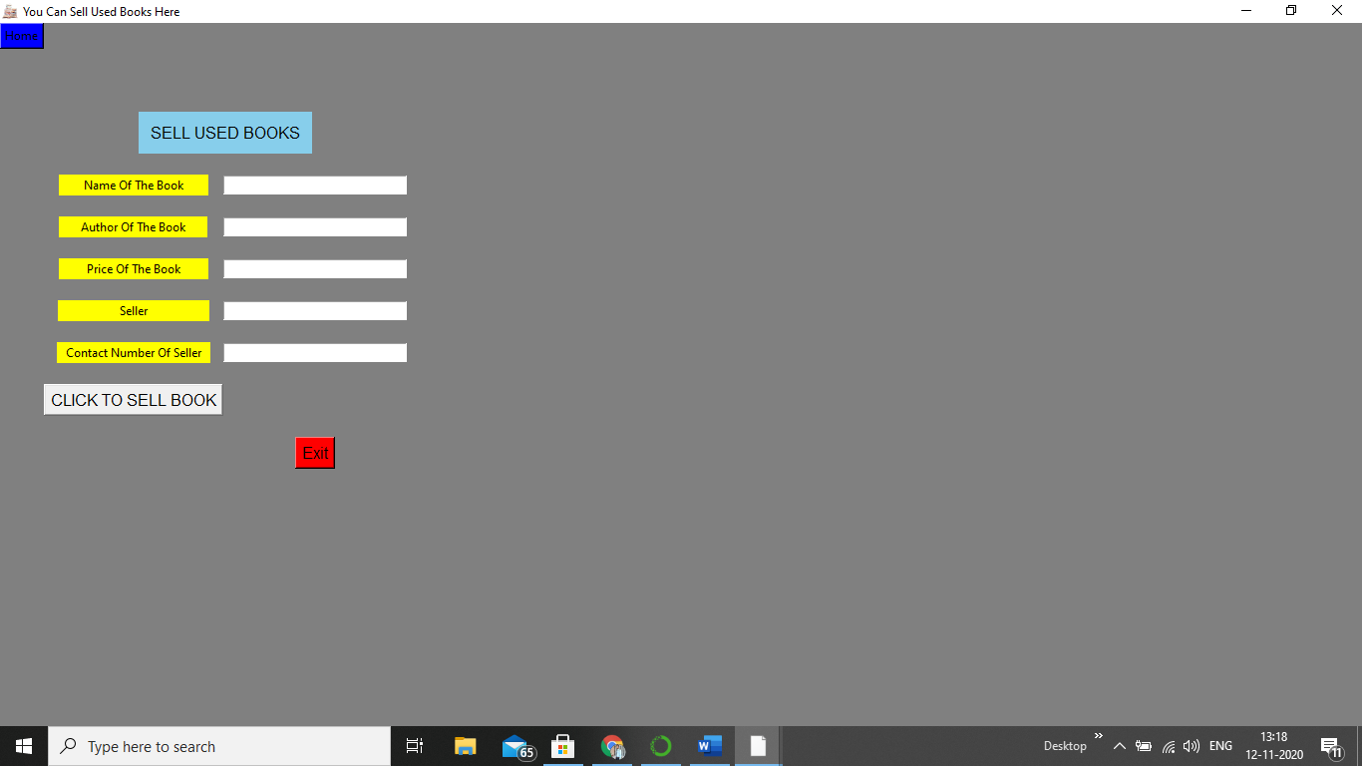

* Buy Used Books

Here we buy books . by presing the button we get payment option like online and ofline . when you press online we kept a message box which displays that the service is out. And in ofline we have to give the address of delivery and then we should type the serial number of the respective book that you want to buy. 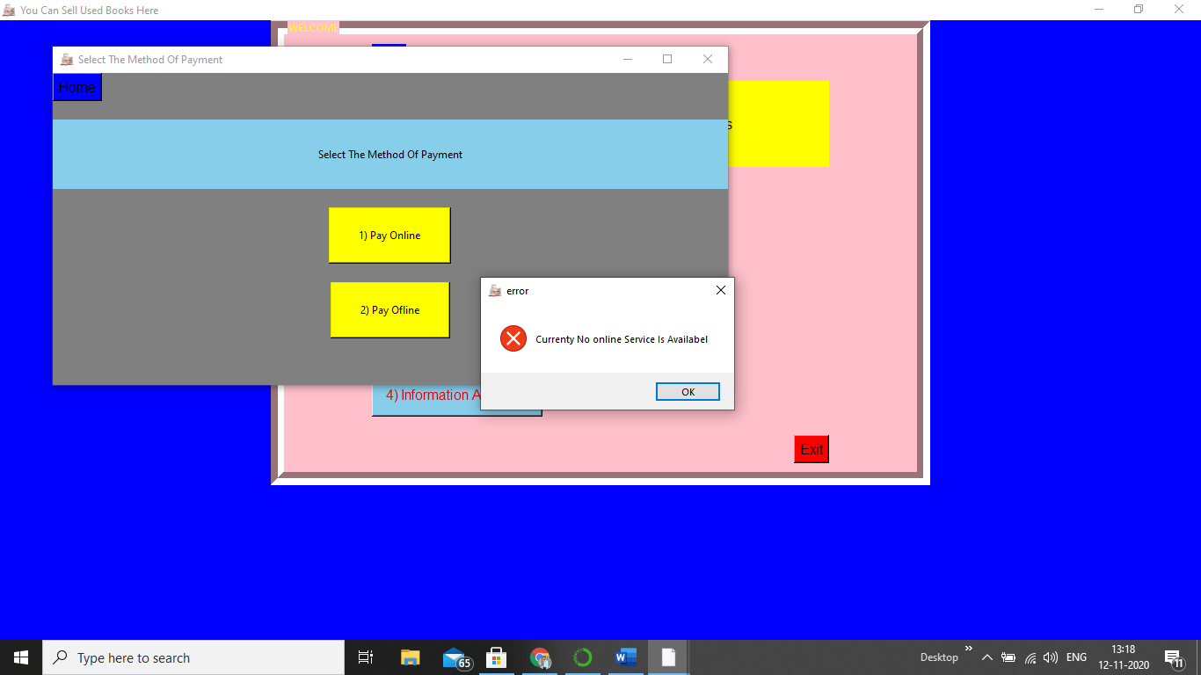

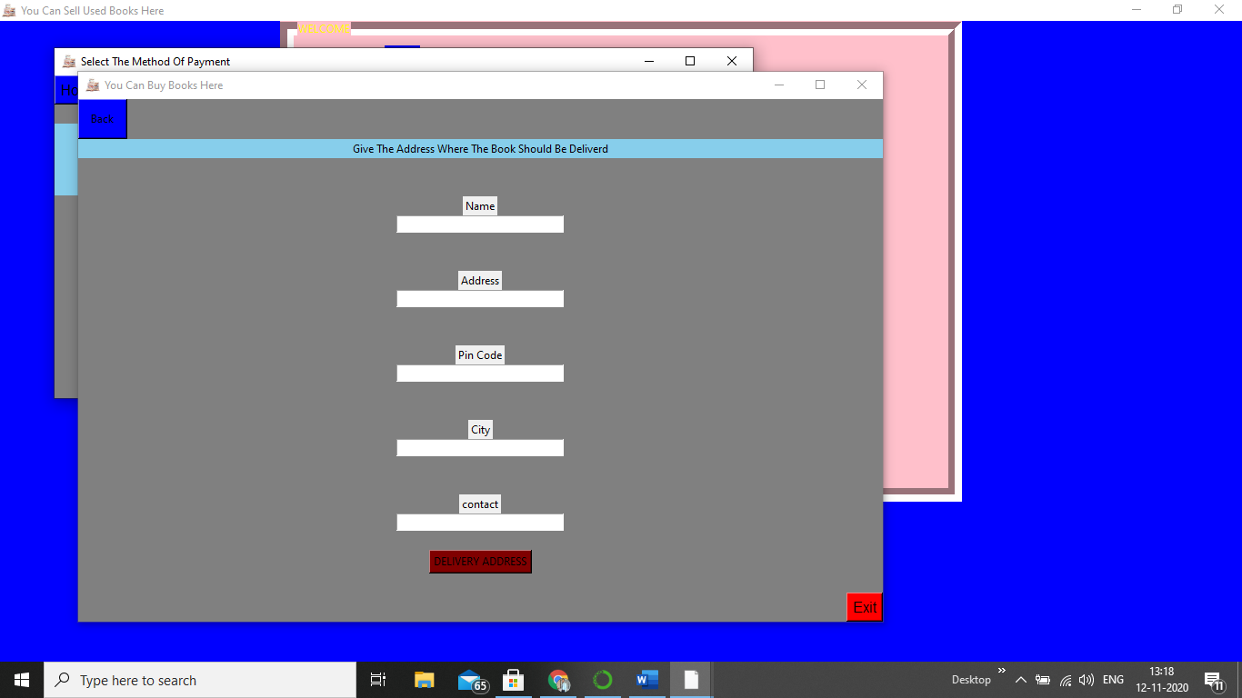

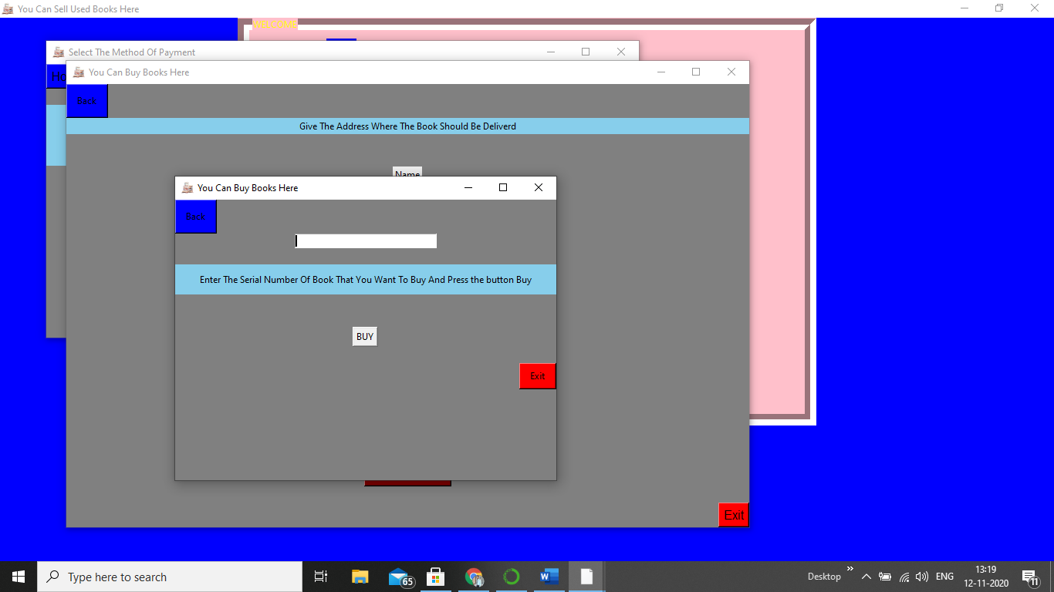

* Our Information

In this we provided a messege box which contains our name and contact number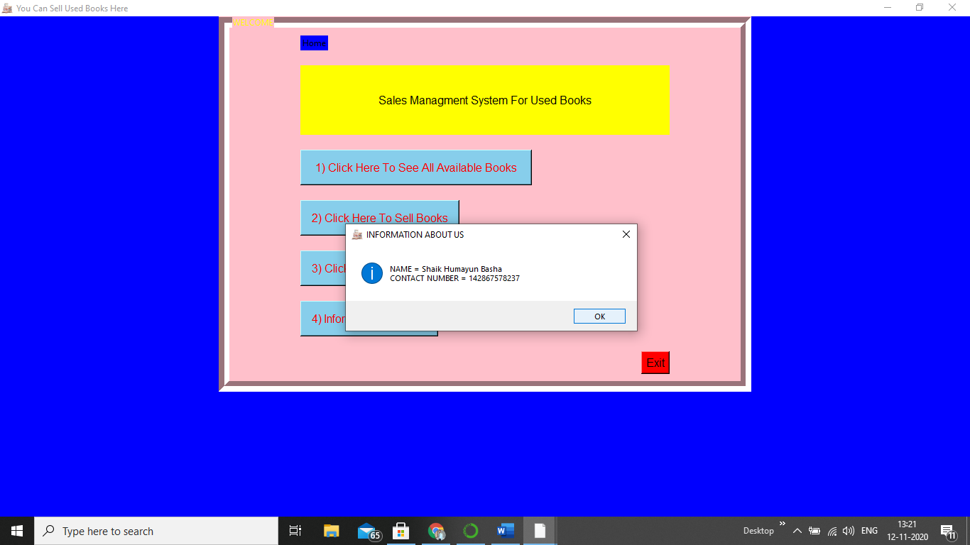

* WIDGETS :

1) Messagebox - MessageBox Widget is used to display the message boxes in the python applications. This module is used to display a message using provides a number of functions

2) Label - This widget implements a display box where you can place text or images. The text displayed by this widget can be updated at any time you want.

3) Entry - The Entry Widget is a Tkinter Widget used to Enter or display a single line of text.

4) **Button**  - The **Button** widget is a standard Tkinter widget used to implement various kinds of buttons. Buttons can contain text or images, and you can associate a Python function or method with each button. When the button is pressed, Tkinter automatically calls that function or method.

5)Frame – The frame creates a special area in windows for which we can create border to present it beautifully.

Layout Managers :

Grid - grid is one of the most flexible layout manager out of the three GUI layout managers in python. It was introduced as an alternative to pack. Grid allows you to position the elements in rows and columns which give you more flexibility to your widgets.